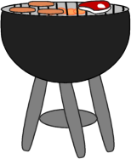Write three words in each category! Name: _______________ Score:_______

5

A Minute Activity Food

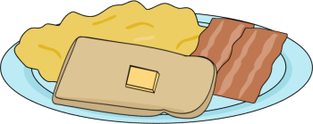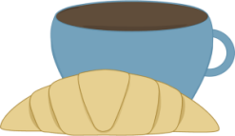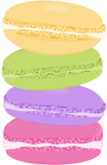

**13**

**14**

**15**

**7**

**8**

**9**

**10**

**12**

**11**

**6**

**5**

**4**

**3**

**2**

**1**

Snacks

Vitamins

Dairy products

Activities in the kitchen

Things in the cupboard

Things on the table

Red fruits

Green vegetables

Desserts

Main courses

Cereals

Food you can deep freeze

Food you can cut

Food you can drink

Food you can fry